______________________________________________________________

UM-SJTU JOINT INSTITUTE

INTRO TO CIRCUITS

(VE 215)

______________________________________________________________

LABORATORY REPORT

LAB 2

Op Amp LAB

|  |  |  |
| --- | --- | --- |
| Name: **Weikai Zhou** | ID: **518021911039** |  |
| Date: 29 October 2019 |  |  |

1. **Introduction [1]**
   1. **Objectives**

* Learn how to build and test a variety of circuits based on LM 741 Op Amp chip: non-inverting and inverting amplifiers with fixed gain.
* Measure the gain of the amplifier and compare it with theoretical calculations.
* Determine the saturated output voltage of the amplifier.
  1. **Apparatus & Theoretical background**
     1. **Op Amp terminals**

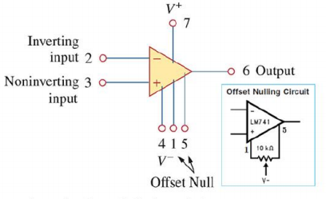Operational amplifiers (Op Amps) are integrated circuits (ICs) used in many applications. In this lab, we will build and study LM741. Below is a circuit symbol of a typical op amp (Figure 1).

Figure 1. Circuit symbol of a typica op amp

There are two terminals for input signals: inverting (labeled -) and non-inverting (labeled +), a terminal for the output signal, two terminals for the power supply voltages: positive + and negative –. In this lab, we will set + = 5V; - = -5V.

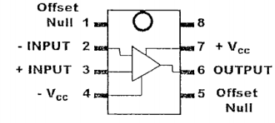Since we will study LM741 in this lab, the real pin numbers of LM741 are shown below (Figure 2).

Figure 2. Pin numbers for LM741 op amp

We should note that pin #8 is not connected; pins #1 and #5 are not used in this lab. We can not mistake the connections of input signals (# 2 labeled – and #3 labeled +) for the connections to the power supply (#4 for - and #7 for +). And we should make sure that we connect the grounds of oscilloscope, function generator and DC source together.

* + 1. **The gain of amplifier circuits**

The amplifier circuits are characterized by their gain values. The voltage gain is the ratio of output voltage to the input voltage in the circuit:

In this lab, we will use oscilloscope to measure the input and output peak-to-peak (ppk) amplitudes of the signals through two channels at the same time.

* + 1. **Inverting amplifier**

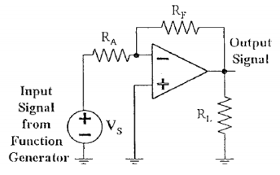The figure below shows an inverting amplifier (Figure 3).

Figure 3. Inverting amplifier.

The theoretical gain of it should be:

* + 1. 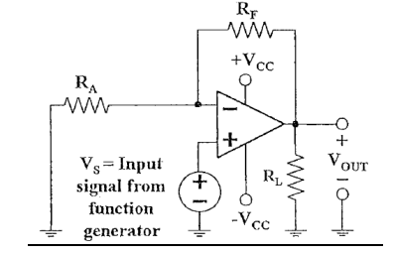**Non-inverting amplifier**

The figure below shows a non-inverting amplifier (Figure 4).

Figure 4. Non-inverting amplifier

The theoretical gain of it should be:

* + 1. **Function generator**

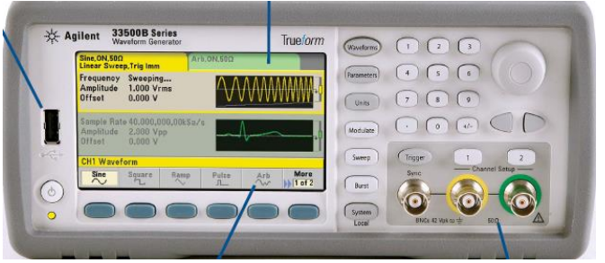The figure below shows the function generator (Figure 5)

Figure 5. Function generator

* The parameter is used to change the amplitude, frequency of wave to generate.

We should note that the amplitude here equals to half of the pp value. For example, if we set a wave whose amplitude is 100mV, the measured pp value would be 200 .

* We can use “1”/ “2” to switch the channel.
  + 1. **Oscilloscope**

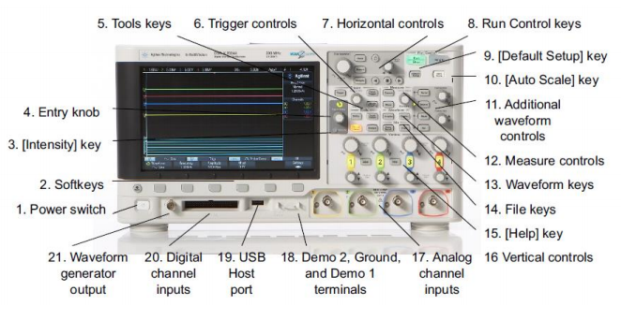The figure below shows the oscilloscope (Figure 6).

Figure 6. Oscilloscope

* We can use “Auto scale” to automatically achieve an output on the screen with proper scale.
* We can use “Meas” to turn on the measurement of the wave.
* We can use “1”/ “2” to show or hide the wave we detecting through channel 1 or 2.

1. **Measurements [1]**
   1. **Non-inverting amplifier**

We will build a non-inverting amplifier in this part.

1. 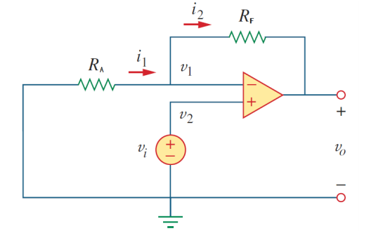We should build the circuit according to the diagram below (Figure 7), where and . We should note that the power supply is going to provide +=+5V and -=-5V to the op amp, and we should use the **COM** port on the power supply as the **ground** in the schematic.

Figure 7. The circuit of non-inverting amplifier

1. We should use the function generator to generate a sine wave, and use it as the input voltage (in the figure above). Then, we should set the initial amplitude of the sine wave to 0.1. And we should use the oscilloscope to measure the output voltage ( in the figure above).
2. Then, we are supposed to increase the input voltage by 0.1 each time and record the corresponding output until the output voltage is saturate, which means the output voltage is not increasing any more as the input voltage increases.
   1. **Inverting amplifier**

We will build an inverting amplifier in this part.

1. We should build the circuit according to the diagram below (Figure 8), where and . We should note that the power supply is going to provide +=+5V and -=-5V to the op amp, and we should use the **COM** port on the power supply as the **ground** in the schematic.

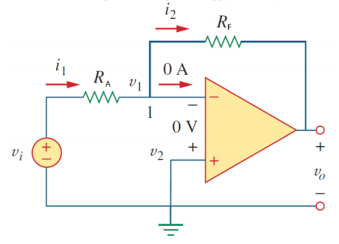 Figure 8. The circuit of inverting amplifier

1. We should use the function generator to generate a sine wave, and use it as the input voltage (in the figure above). Then, we should set the initial amplitude of the sine wave to 0.1. And we should use the oscilloscope to measure the output voltage ( in the figure above).
2. Then, we are supposed to increase the input voltage by 0.1 each time and record the corresponding output until the output voltage is saturate, which means the output voltage is not increasing any more as the input voltage increases.
3. **Results & discussion**
   1. **Non-inverting amplifier**

According to the procedure described in 2.1., we get Table 1 for measurements of the input and output voltage of the non-inverting amplifier as shown below.

|  |  |
| --- | --- |
|  |  |
| 0.1 | 0.34 |
| 0.2 | 0.64 |
| 0.3 | 1.00 |
| 0.4 | 1.32 |
| 0.5 | 1.46 |
| 0.6 | 1.72 |
| 0.7 | 2.00 |
| 0.8 | 2.28 |
| 0.9 | 2.56 |
| 1.0 | 2.84 |

Table 1. Measurements of the input and output voltage of the non-inverting amplifier

Based on the results presented in Table 1, we can use Origin to apply linear fit, as shown in Figure 9.

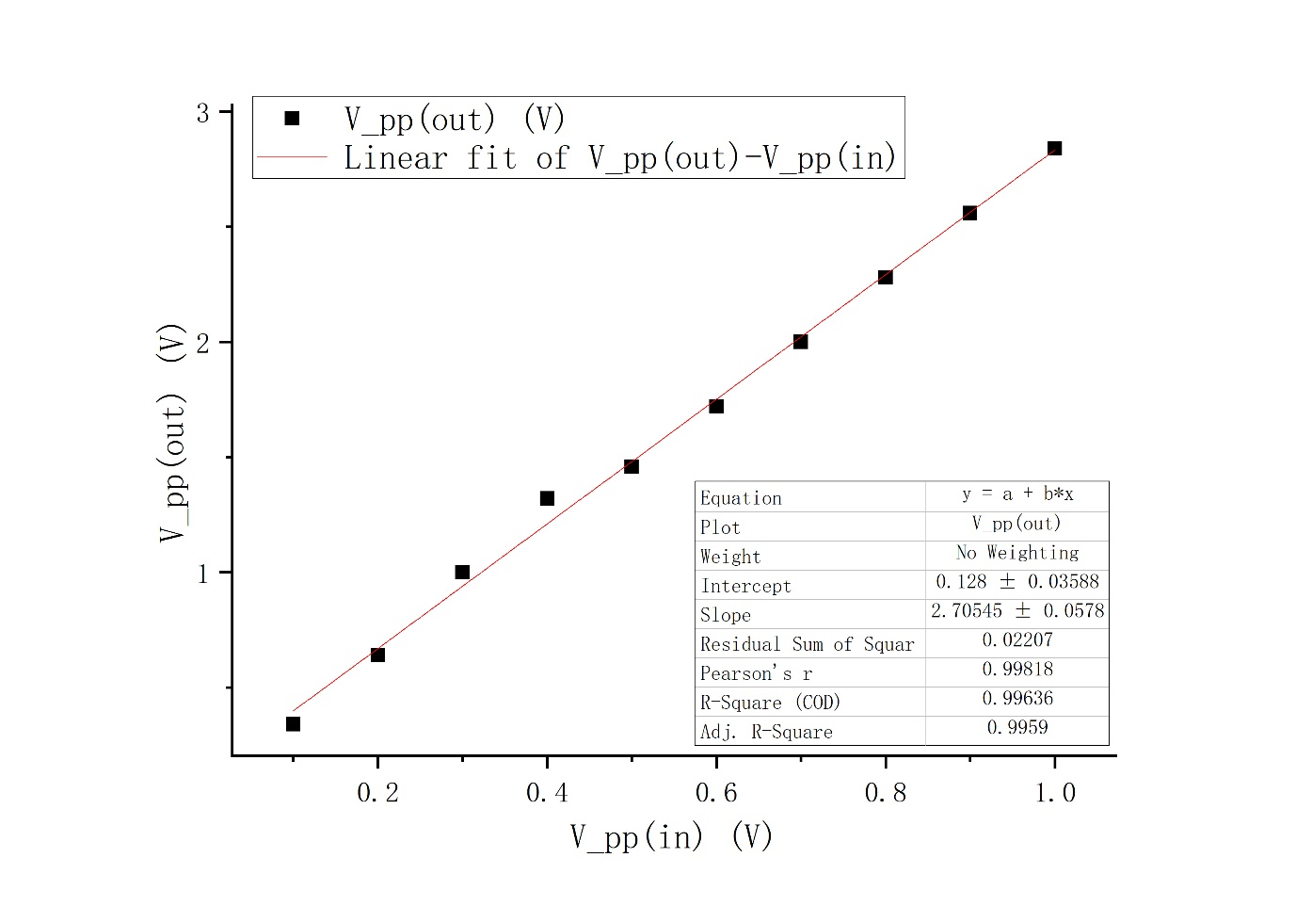Figure 9. Non-inverting -

From this figure, we may conclude that in some region, the - is linearly related since and Pearson’s R are both close to 1. And the average gain shown in the figure is 2.71. The relative error is:

Then, we may calculate the gain for each data point with the formula that and get the table below (Table 2).

|  |  |
| --- | --- |
|  | Gain |
| 0.1 | 3.40 |
| 0.2 | 3.20 |
| 0.3 | 3.33 |
| 0.4 | 3.30 |
| 0.5 | 2.92 |
| 0.6 | 2.87 |
| 0.7 | 2.86 |
| 0.8 | 2.85 |
| 0.9 | 2.84 |
| 1.0 | 2.84 |

Table 2. Gain for each input of the non-inverting amplifier

Based on the results presented in Table 2, we can use Origin to draw the graph, as shown in Figure 10.

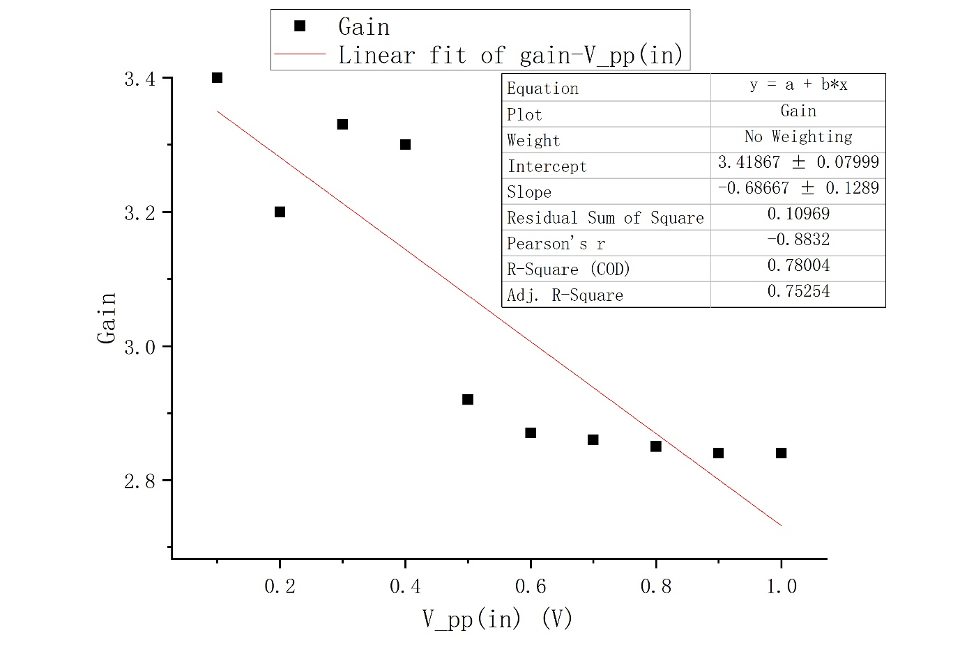Figure 10. Non-inverting Gain-

From this figure, we cannot conclude that there is some special relation between gain and since and Pearson’s R are both not close to 1. But we can still find that the tendency for gain is to drop with the increase of .

Overall, based on our data, we can see that the real gain of the non-inverting amplifier we used is around 2.71, which is smaller than the theoretical value, which is 3, and the relative error is 9.67%. We may think this is because of the non-ideal instruments. The equipment we used in lab is not ideal, for example, the wire has resistance. Moreover, since we used a breadboard to help us connect the circuit, it may contribute to the bad connection. After the lab, we find that the output voltage has not achieved saturate state yet, so our conclusion may not be comprehensive. And we may predict that with the further increase of , gain will further decrease, and will finally become a stable value.

* 1. **Inverting amplifier**

According to the procedure described in 2.2., we get Table 3 for measurements of the input and output voltage of the inverting amplifier as shown below.

|  |  |
| --- | --- |
|  |  |
| 0.1 | 0.136 |
| 0.2 | 0.240 |
| 0.3 | 0.344 |
| 0.4 | 0.444 |
| 0.5 | 0.548 |
| 0.6 | 0.644 |
| 0.7 | 0.748 |
| 0.8 | 0.888 |
| 0.9 | 0.992 |
| 1.0 | 1.10 |

Table 3. Measurements of the input and output voltage of the inverting amplifier

Based on the results presented in Table 3, we can use Origin to apply linear fit, as shown in Figure 11.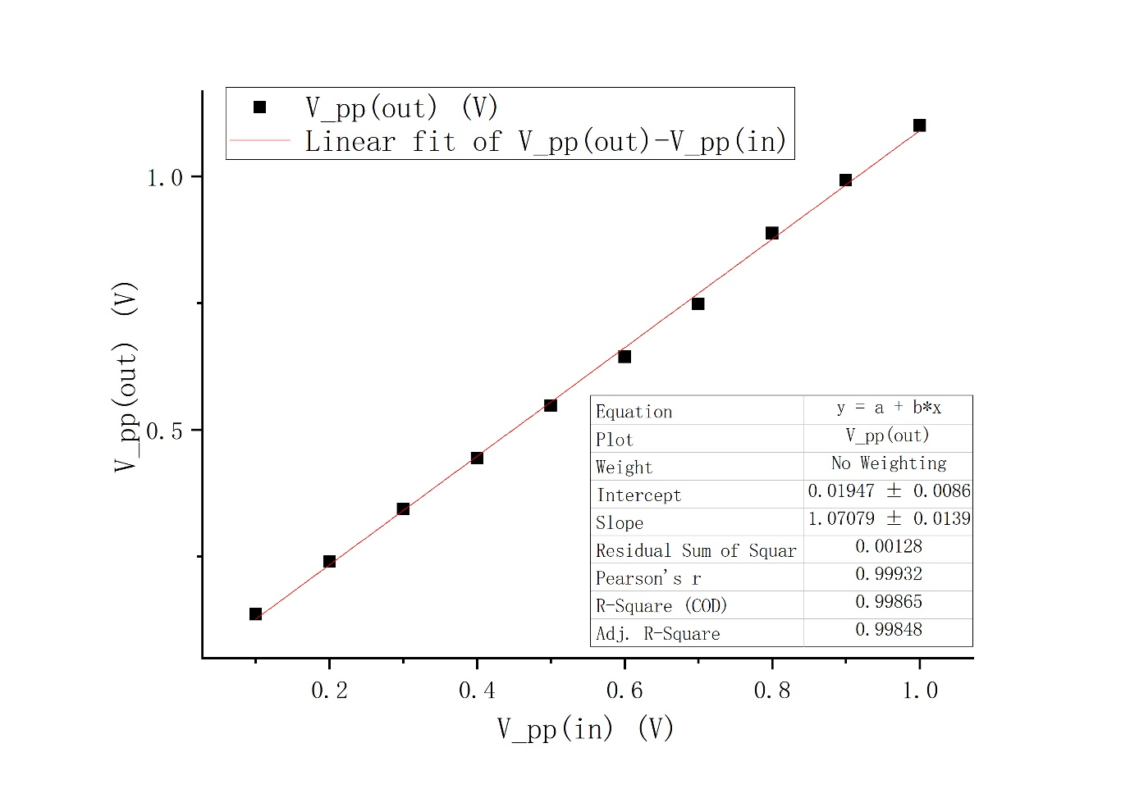

Figure 11. Inverting -

From this figure, we may conclude that in some region, the - is linearly related since and Pearson’s R are both close to 1. And the average gain shown in the figure is 1.07. And the relative error is:

Then, we may calculate the gain for each data point with the formula that and get the table below (Table 4).

|  |  |
| --- | --- |
|  | Gain |
| 0.1 | 1.36 |
| 0.2 | 1.20 |
| 0.3 | 1.15 |
| 0.4 | 1.11 |
| 0.5 | 1.10 |
| 0.6 | 1.07 |
| 0.7 | 1.07 |
| 0.8 | 1.11 |
| 0.9 | 1.10 |
| 1.0 | 1.10 |

Table 4. Gain for each input of the inverting amplifier

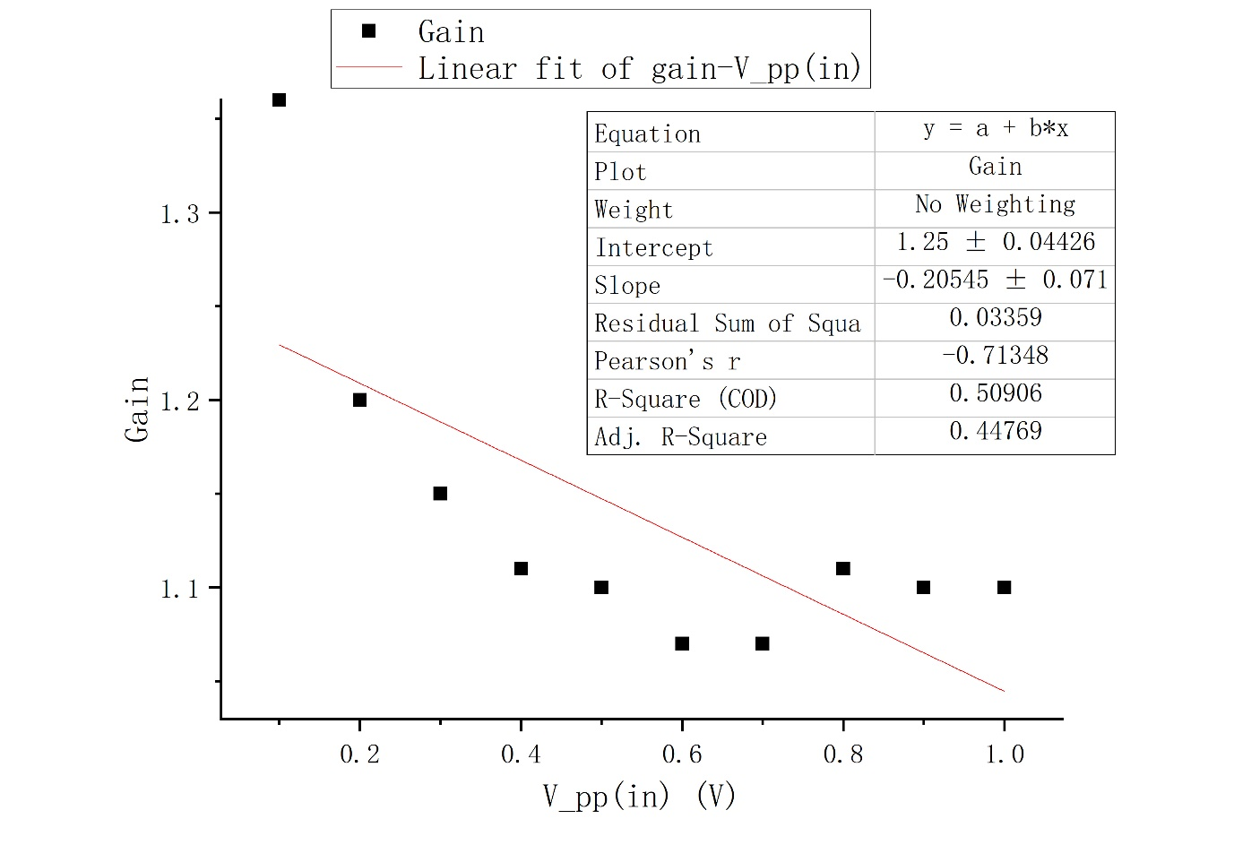 Based on the results presented in Table 4, we can use Origin to draw the graph, as shown in Figure 12.

Figure 12. Inverting Gain-

From this figure, we cannot conclude that there is some special relation between gain and since and Pearson’s R are both not close to 1. But we can still find that the tendency for gain is to drop with the increase of .

Overall, based on our data, we can see that the real gain of the non-inverting amplifier we used is around 1.07. However, the theoretical value of gain is -2, and the relative error is 153.5%. We first may think this is because of wrong connection of the circuit. But after we checked it many times, there seems to be no problem with our circuit. Then we think there may be problem with LM741 because after we change another LM741, the value changes. Besides, the oscilloscope may only display positive voltage values, which will further increase the deviation from the theoretical value. Moreover, it may also due to the non-ideal instruments. The equipment we used in lab is not ideal, for example, the wire has resistance. Moreover, since we used a breadboard to help us connect the circuit, it may contribute to the bad connection. After the lab, we find that the output voltage has not achieved saturate state yet, so our conclusion may not be comprehensive. And we may predict that with the further increase of , gain will further decrease, and will finally become a stable value.

1. **Conclusions [1]**

In this experiment, we learn how to build and test a variety of circuits based on LM 741 Op Amp chip: non-inverting and inverting amplifiers with fixed gain. We also learn how to measure the gain of the amplifier and compare it with theoretical calculations and determine the saturated output voltage of the amplifier. Most objectives have been achieved. Therefore, the experiment is quite successful.

During the experiment, we find that the real gain for non-inverting amplifier is close to the theoretical value while the real gain for inverting amplifier is away from the theoretical value.

We consider that this may be because of the wrong circuit connection, the non-ideal instrument, the way of connection and so on.

In order to solve these problems as much as possible, we can repeat the experiment with different equipment and use Pspice to help us.

Moreover, we should take more data since we need to determine the saturated output voltage of the amplifier.

1. **References**

[1] Lab 2_Opamp_Manual.pdf